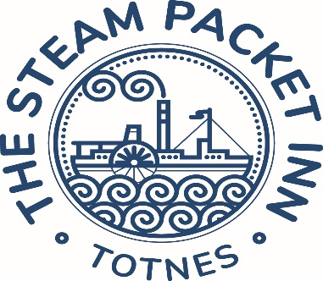Sunday menu…

Starters…

**Soup of the day** fresh bread **£7.50 (GFO) (VE)**

**Smoked mackerel pate** charred lemon & toast **£8.50 (GFO)**

**Tomato & mozzarella salad** balsamic glaze, croutons & basil pesto **£8 (VE)**

**Breaded whitebait** lemon & dill mayo & salad **£8**

**Spiced turmeric hummus** crispy chickpeas, toasted sesame & flatbread **£7.50 (VE) (GFO)**

**Classic nachos** mozzarella, jalapenos, salsa, guacamole & sour cream **£8 (V)**

*add chilli beef* ***£3 (GF)***

Sunday Roast…

**Roast sirloin of Devon beef** horseradish sauce **£18.50**

**Roast loin of Devon pork** apple sauce **£17.50**

**Roast leg of Devon lamb** mint sauce **£18.50**

**Nut Roast £16.50**

*with Yorkshire pudding(v) without Yorkshire pudding (ve)*

All served with Yorkshire pudding, roast potatoes, seasonal vegetables & gravy

*All roasts can be offered gluten free without Yorkshire pudding*

Mains…

**Fillet of bream** crushed new potatoes & wilted spinach; cherry tomato, balsamic red onion & basil dressing **£19 (GF)**

**Cous Cous salad** sundried tomatoes, balsamic onion, roasted butternut squash, roasted red pepper, coriander, lime, pomegranate, orange vinaigrette & raisin purée **£16.50 (VE)**

**Honey & mustard glazed ham** free range egg, chips & peas **£15.50 (GF)**

**Fresh Brixham haddock** beer & dill batter, chips, mushy peas & tartare sauce **£17.50**

**Beyond Meat vegan burger** lettuce, tomato & red onion, smoked Applewood cheese & barbeque sauce, fries & slaw **£16 (VE) (GFO)**

Desserts…

**Warm treacle tart** clotted cream **£8**

**Vanilla crème Brulee** shortbread biscuit **£8 (GFO)**

**Raspberry frangipane** vegan vanilla ice cream **£8 (VE/GF)**

**Chocolate brownie** chocolate sauce & vanilla ice cream **£8**

**Selection of local cheeses** chutney, crackers, apple & grapes **£10**

**Salcombe Dairy Ice creams**

**1 scoop £3.00 – 2 scoops £5.50 – 3 scoops £7.00**

Vanilla – Chocolate – Strawberries & cream – Honeycomb – Mint choc chip

Mango Sorbet (VE) - Vegan Vanilla (VE)

Sandwiches…

(Available from 12.00-6pm)

Served on Hallett’s bread with salad & crisps

Swap crisps for fries, £2.00 extra

**Smoked salmon £9**

lemon & dill mayo & cucumber

**Roast beef £9**

Horseradish sauce & mixed leaves

**Mature Cheddar Cheese £8 (V)**

Ale chutney

**Honey & Mustard Glazed Ham £9**

English mustard & salad

**Fresh crab £13**

lemon & chive mayo

Kids menu…

All meals served with chips & beans or peas

**Fish Fingers**

**Chicken breast chunks**

**Pork Sausages**

**Vegan Sausages (VE)**

**Ham & Egg (GF)**

**All £7.50**

Sunday Roast…

**Roast topside of beef** horseradish sauce **£9**

**Roast loin of pork** apple sauce **£9**

**Roast leg of lamb** mint sauce **£9**

**Nut Roast £9**

*with Yorkshire pudding(v) without Yorkshire pudding (ve)*

All served with Yorkshire pudding, roast potatoes, seasonal vegetables & gravy

*All roasts can be offered gluten free without yorkshire pudding*