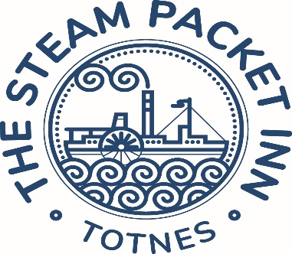

Starters…

**Soup of the day** warm baguette **£8 (VE) (GFO)**

**Spiced Tempura Hake** coriander & mint chutney, pomegranate seeds **£9.50**

**Crab fishcake** lemon mayo, salad **£10 (V)**

**Butternut squash hummus**, crispy sage & flatbread **£9 (GFO) (VE)**

**Maple glazed duck salad** orange segments, rocket & watercress **£10 (GF)**

**Smoked salmon** capers, black pepper & lemon; bread & butter **£11 (GFO)**

**Classic nachos** mozzarella, jalapenos, salsa, guacamole & sour cream **£9.50 (V)**

- *add chilli beef* ***£3 (GF)***

Mains…

**Fillet of seabass** new potatoes, roasted tomatoes, spinach & pesto cream **£20**

**Tomato & basil penne pasta** parmesan, garlic bread **£14 (V)**

**Sweet chilli pork** basmati rice **£16.00**

**Steam Packet steak burger** Monterey jack cheese, burger relish, lettuce, tomato

& red onion served in a brioche bun, fries & slaw **£17** add streaky bacon **£2 (GFO)**

**Fresh Brixham haddock** beer batter, fries, mushy peas, homemade tartare sauce **£18.50**

**Breaded wholetail scampi** fries, homemade tartare sauce, mixed salad **£16.50**

**Honey & mustard glazed ham** fried eggs, fries & peas **£16.50 (GF)**

**Beyond Meat vegan burger** lettuce, tomato & red onion, smoked applewood cheese & barbecue sauce, fries & slaw **£16 (VE) (GFO)**

**Butchers Sausages** bubble & squeak, roasted baby carrots & caramelised onion gravy **£16**

**Steak & ale pie** topped with puff pastry; fries & garden peas **£17**

**Creamy mushroom & stilton linguini** lemon & herb crumb **£16 (V)**

Sides…

|  |  |
| --- | --- |
| Side salad £3.50 | Fries £4 |
| Rocket & parmesan salad £5 | Cheesy fries £5 |
| Onion rings £4  Garlic ciabatta £4 | New potatoes £4  Garlic ciabatta with cheese £5 |
|  |  |

Sandwiches…

(Available from 12.00-2.30pm)

Served on Hallett’s Bakery white bread

Gluten free bread available

Served with salad & crisps

**Swap crisps for fries, £2.00 extra**

**Prawn & marie rose sauce £11**

Gem lettuce

**Proper fish finger £11**

Homemade tartare sauce & gem lettuce

**Brie & cranberry sauce £9 (V)**

*Add bacon £2*

**Honey & mustard glazed ham £9.50**

English mustard & tomato

**Mature cheddar cheese £9.50**

Ale chutney

Children’s menu…

All meals served with fries & beans or peas

**Fish fingers**

**Chicken chunks**

**Pork sausages**

**Vegan sausages (VE)**

**Ham & egg (GF)**

**All £8.50**

**We are proud to use local suppliers & support local  
businesses where possible & currently use.**  
Salcombe Dairy  
Kingfisher

M.C.Kelly  
Wright Brothers

VE =vegan, V = vegetarian, GF = gluten free, GFO = gluten free option available on request  
Nuts are used in our kitchen & dishes may contain nuts or nut oils.  
Customers with food allergies are asked to discuss their dietary needs with our staff prior to ordering