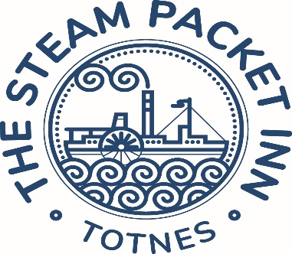Mothering Sunday 2025

Starters…

**Pea & mint soup** warm baguette **(GFO) (VE)**

**Smoked salmon & prawn salad** marie rose sauce **(GFO)**

**Melon & parma ham** rocket salad & balsamic glaze **(GF)**

**Baked camembert** honey & rosemary; toasted ciabatta **(GFO)**

**Red pepper hummus** toasted nuts & seeds & flatbreads **(GFO) (VE)**

**Breaded mushrooms** garlic & chive mayonnaise

Mains…

**Roast topside of beef** horseradish sauce

**Roast leg of pork** apple sauce

**Nut Roast**

*with Yorkshire pudding(v) without Yorkshire pudding & cauliflower cheese(ve)*

All served with Yorkshire pudding, roast potatoes, seasonal vegetables & gravy

*All roasts can be offered gluten free without yorkshire pudding*

**Smoked salmon, mussel & prawn linguine** white wine & dill cream sauce

**Goats cheese & red onion tart** new potatoes & salad **(V)**

**Cauliflower & apricot tagine** lemon & herb couscous **(VE)**

**Spinach & garlic gnocchi** roasted butternut squash & broccoli, butternut squash puree, vegan pesto & crispy kale **(VE) (GF)**

**Butcher’s sausages** mashed potatoes, kale & caramelised onion gravy **(GF)**

Desserts…

**Sherry trifle** sherry soaked sponge fingers in raspberry jam, custard & Chantilly cream

**Toasted coconut rice pudding** rhubarb compote **(GF) (VE)**

**Warm treacle tart** clotted cream

**Dark chocolate pot** chocolate orange crumb **(GF) (VE)**

**Selection of local cheeses** quince jelly, crackers, apple & grapes **(GFO)**

**2 course £26**

**3 course £32**

A small selection of other dishes are available on a separate a la carte menu